H.T No
Regulations:
A18

Sreenidhi Institute of Science and Technology
(An Autonomous Institution)
Code No:7K404 Date: 05-Dec-2020 (FN)

B.Tech II-Year II-Semester External Examination, Nov/Dec - 2020 (Regular)
MECHANICS OF MATERIALS (CIVIL)

Time: 2 Hours Max.Marks:70

Note: a) No additional answer sheets will be provided.
b) All sub-parts of a question must be answered at one place only, otherwise it will not be valued.
c) Missing data can be assumed suitably.

ANSWER ANY 5 OUT OF 8 QUESTIONS. EACH QUESTION CARRIES 14 MARKS.

1. |  | A bar of 30 mm diameter is subjected to a pull of 6 tonnes. The measured extension on gauge length of 20 cms is 0.09 mm and the change in diameter is 0.0039 mm. calculate the poissions ration and the values of the three moduli (Young’s modulus, bulk modulus and modulus of rigidity). | [14M]
2. |  | A bolt is subjected to a tensile load of 18 kN and a shear load of 12 kN. The material has an yield stress of 328.6 MPa. Taking factor of safety as 2.5, Possions ratio as 0.298, determine the core diameter of bolt according to the following theories of failure:  i) Rankines theory ii) Saint Venant’s theory | [14M]
3. | a) | Find the loading on the beam and draw the bending moment diagram for a given shear force diagram of a loaded beam.  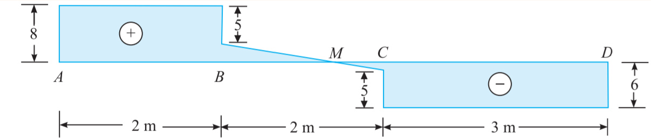 | [7M]
 | b) | A horizontal beam 10 m long is carrying a uniformly distributed load of 1 kN/m. The beam is supported on two supports 6 m apart. Find the position of the supports, so that bending moment on the beam is as small as possible. Also draw the shear force and bending moment diagrams. | [7M]
4. |  | Determine the vertical and horizontal deflections at the point “B” of the truss shown in figure.  EA = Constant  E = 200 GPa  A = 1200 mm²  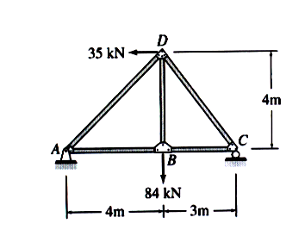 | [14M]
5. |  | A cantilever of uniform section has a length “l”. It is propped at the free end carries a point load W at a distance “a” from the fixed end. If the prop holds the free end at the level of fixed end, find the prop reaction. If now the prop is removed what will be the deflection at the free end? | [14M]
6. | a) | Derive an expression for Euler’s buckling load for column with (i) both ends fixed (ii) one end is fixed and the other free. | [7M]
 | b) | A bar of length 4m when used as a simply supported beam and subjected to a uniformly distributed load of 3 tonnes/m over the whole span deflects 1.5cm at the centre. Determine the crippling loads when it is used as a column with the following conditions.  - Both ends hinged  - One end is fixed and other hinged | [7M]
7. |  | A stepped bar is subjected to external loading as shown in figure. Determine the magnitude of axial force P such that net deformation in the bar does not exceed 2mm. E for steel is 200GP and that of copper is 100GPa. Large diameter and smaller diameters are 40mm and 15mm respectively.  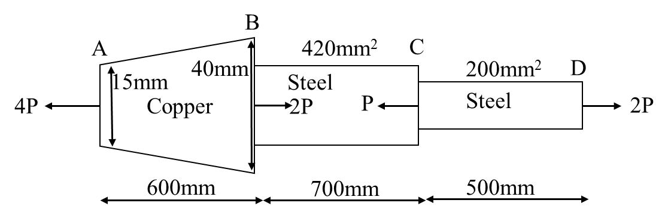 | [14M]
8. | a) | The stresses acting at a point in a two dimensional system is shown in figure. Determine the principal stresses and planes, maximum shear stress and planes, normal and shear stresses on plane AB.  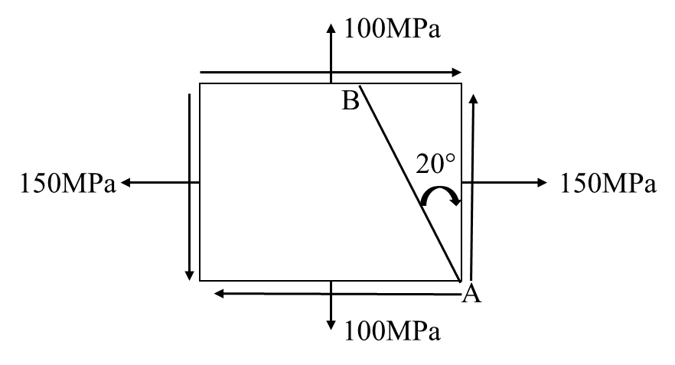 | [7M]
 | b) | Derive expression for principal stresses and their planes for a two dimensional stress system. | [7M]

-- 00 -- 00 –

